KAP/PBNC 2026 Sponsorship Invitation

KAP/PBNC 2026 invites leading companies and organizations to partner with us as valued sponsors of this premier international nuclear conference.

Held jointly as a unified global platform, KAP/PBNC 2026 will bring together policymakers, industry executives, technical experts, researchers, and innovators from across the nuclear sector. The event will serve as a focal point for dialogue on industrial applications, emerging technologies, regulatory developments, and the future direction of nuclear energy worldwide.

By becoming a sponsor, your organization will gain strategic visibility among key decision-makers and technical leaders shaping the global nuclear landscape. Sponsorship provides a distinctive opportunity to:

- Enhance brand positioning within the international nuclear community
- Showcase products, technologies, and services to a targeted professional audience
- Strengthen corporate reputation and industry leadership
- Expand business networks through high-level engagement opportunities
- A range of tailored sponsorship packages is available, offering diverse branding, speaking, exhibition, and networking benefits to maximize your return on participation.

We welcome your partnership in making KAP/PBNC 2026 a dynamic and impactful gathering for the global nuclear industry.

For sponsorship inquiries, please contact: conference@kaif.or.kr

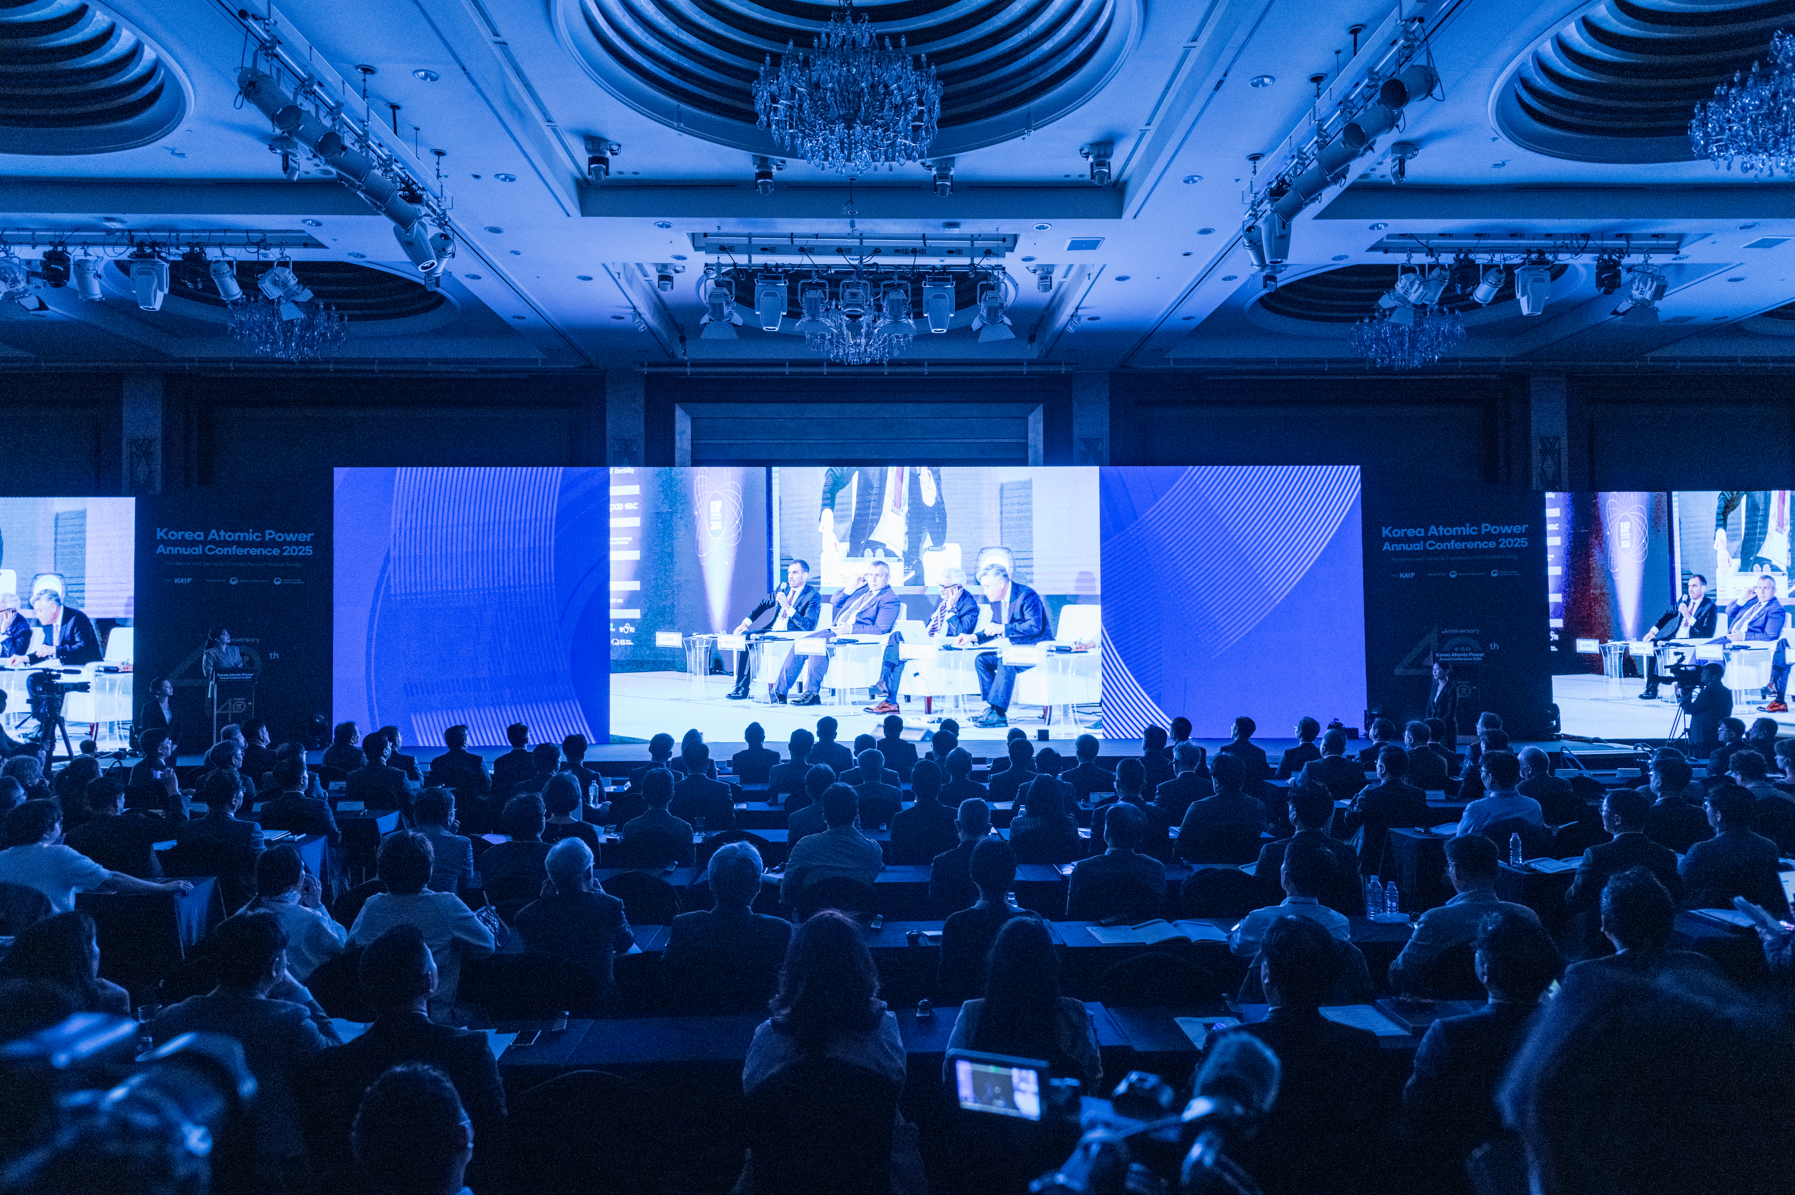 | 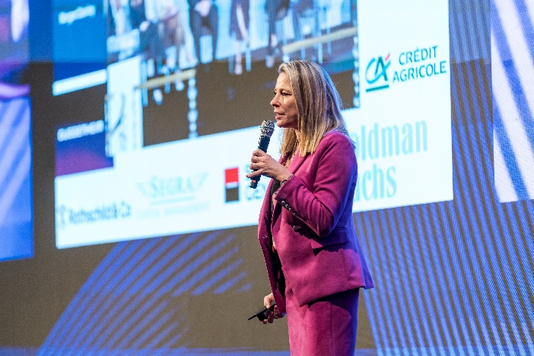

Sponsorship Program and Benefits

STAR (KRW 75,000,000) – Limited Availability (2)
■ On-site Branding & Visibility
- Featured Pitching Session at the INEX Presentation Hall
  - Up to 30 minutes total (20-minute pitch + 10-minute networking)
- Dedicated branded table at the PBNC & KAP 2026 Gala Dinner
- Brand exposure on official lanyards and badge inserts used by all PBNC & KAP 2026 participants
- Exclusive on-site meeting room within the INEX exhibition hall (1 room)
Ideal for private meetings with Korean utilities, EPCs, and supply-chain partners
- High-impact brand visibility across the venue, including:
main stage backdrop, front LED screens, large-scale installations, and other premium locations
- VIP Luncheon Sponsor recognition, including the opportunity to deliver a welcoming toast
- Opportunity to deliver a toast during the official reception
■ Media & Marketing Exposure
- Integrated sponsor visibility across official event channels:
① Conference newsletter (including promotion of the pitching session)
② Official programs (online and onsite)
③ Full-page advertisement (2 pages) in the official program book
④ Sponsor acknowledgment in official press releases
■ Delegate & Hospitality Benefits
- 13 complimentary full conference registrations (Total value: KRW 20,000,000)
- 8 Gala Dinner invitations / 5 VIP Luncheon invitations
DIAMOND (KRW 50,000,000) – Limited Availability (3)
■ On-site Branding & Visibility
- Dedicated pitching session at the INEX Presentation Hall
  - Up to 30 minutes total (20-minute pitch + 10-minute networking)
- Dedicated branded table at the PBNC & KAP 2026 Gala Dinner
- Brand exposure on PBNC & KAP 2026 badge inserts
- Exclusive on-site meeting room within the INEX exhibition hall (1 room)
- Large-scale brand visibility across premium locations, including
the main stage, front LED screens, large installations, and other designated high-traffic areas
- Opportunity to deliver a toast during the official reception
- Recognition as Gala Dinner Sponsor, including the opportunity to deliver a toast
■ Media & Marketing Exposure
- Sponsor brand exposure across official event channels:
① Conference newsletter (including promotion of the pitching session)
② Official programs (online and onsite)
③ Full-page advertisement (1 page) in the official program book
④ Sponsor acknowledgment in official press releases
■ Delegate & Hospitality Benefits
- 10 complimentary full conference registrations (Total value: KRW 15,000,000)
- 8 Gala Dinner invitations / 3 VIP Luncheon invitations

PLATINUM (KRW 30,000,000)
■ On-site Branding & Visibility
- Large-scale logo exposure on the main stage, front LED screens, and major on-site installations
- Recognition as Coffee Break Sponsor
■ Media & Marketing Exposure
- Sponsor brand exposure through official event materials:
① Official programs (online and onsite)
② Full-page advertisement (1 page) in the official program book
■ Delegate & Hospitality Benefits
- 7 complimentary full conference registrations (Total value: KRW 10,000,000)
- 5 Gala Dinner invitations / 2 VIP Luncheon invitations
GOLD (KRW 20,000,000)
■ On-site Branding & Visibility
- Medium-size logo exposure on the main stage, front LED screens, and major on-site installations
■ Media & Marketing Exposure
- Sponsor logo exposure in official event programs (online and onsite)
■ Delegate & Hospitality Benefits
- 5 complimentary full conference registrations (Total value: KRW 7,700,000)
- 3 Gala Dinner invitations / 1 VIP Luncheon invitation
SILVER (KRW 10,000,000)
■ On-site Branding & Visibility
- Medium-size logo exposure on the main stage, front LED screens, and major on-site installations
■ Media & Marketing Exposure
- Sponsor logo exposure in official event programs (online and onsite)
■ Delegate & Hospitality Benefits
- 3 complimentary full conference registrations (Total value: KRW 5,000,000)
- 2 Gala Dinner invitations / 1 VIP Luncheon invitation
BRONZE (KRW 5,000,000) – For Domestic SMEs
■ On-site Branding & Visibility
- Small-size logo exposure on the main stage, front LED screens, and major on-site installations
■ Media & Marketing Exposure
- Sponsor logo exposure in official event programs (online and onsite)
■ Delegate & Hospitality Benefits
- 1 complimentary full conference registrations (Total value: KRW 1,500,000)

Sponsorship Program Application Form

I hereby submit the application for participation in the sponsorship program of
Pacific Basin Nuclear Conference and Korea Atomic Power Annual Conference 2026.

Applying Program
Corporate Name
Address
Person in Charge | (Name) | (Signature)
Person in Charge | (Affiliation/Job Title)
Person in Charge | (TEL.)
Person in Charge | (E-Mail)
Person in Charge | (Emergency Contact and 2nd Person in Charge)

<Note>
- Please fill all the blanks of the application form and return it to the conference secretariat.
- For further information needed such as records in past events on the sponsorship program, please feel free to contact the conference secretariat.
- The payment invoice will be provided upon your request.


Please return this form to PBNC/KAP 2026 Conference Secretariat
KOREA ATOMIC INDUSTRIAL FORUM, Inc.
Jinsil Kim (Ms.) (T. +82-2-6257-2591 / kimjs@kaif.or.kr)

